ST ANDREW’S METHODIST PRIMARY SCHOOL

STRIVING FOR EXCELLENCE-
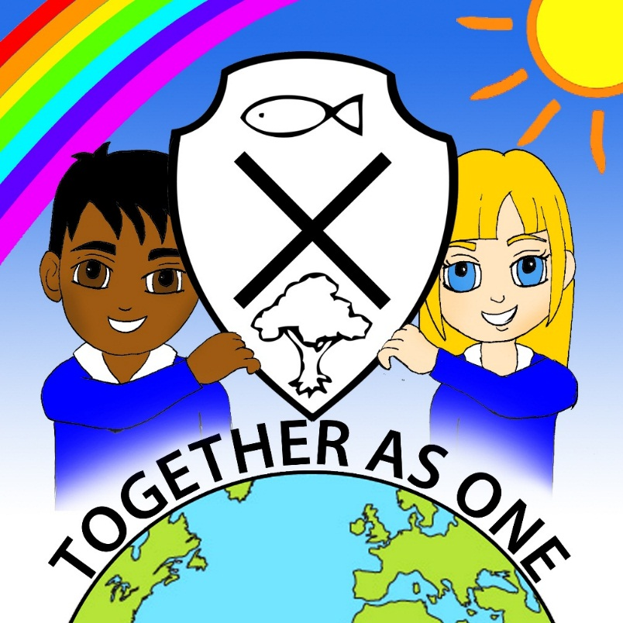
WITH GOD

Geography Policy

Reviewed January 2026

Headteacher Date:

Chair/Vice Chair of Governing Board Date:

Date of Next Review January 2028

This policy has been scrutinized to ensure it meets the requirements of the single equality duties. The school will make every reasonable adjustment to comply with the duties and actively avoid discrimination.

Intent

This policy reflects St. Andrew’s Methodist Primary School’s, values and philosophy to the teaching and learning of geography. Our geography policy is underpinned by the school’s Christian vision, ‘Striving for excellence, together as one with God.’
We aim to stimulate the children’s’ curiosity about the world we live in, as well as learning and understanding about our own local environment. We promote the school’s Methodist values through our geography curriculum by ensuring all children care about, and have a clear, respectful understanding of, different cultures and current global issues. Pupils engage in discussions about significant events and places. They learn to be knowledgeable about, and respectful of, a variety of traditions and beliefs.

Geography teaches an understanding of places and environments, the human and physical processes, which shape them and the people who live in them. We help pupils gain place knowledge and understanding of Britain and that of the wider world. Through their growing knowledge and understanding of human geography, children gain an appreciation of life in different cultures.

Children study their local area and compare their life in this area with contrasting places in the United Kingdom and other parts of the world. The study of the local area forms an important part of the geography taught at our school and planned activities build upon the children's knowledge and understanding of the locality in which they live.

Pupils learn how to draw and interpret maps and develop the skills of research, investigation, analysis and problem-solving. Our geography teaching motivates children to find out about the physical world and enables them to recognise the importance of sustainable development for the future of mankind.

We want our pupils to develop an understanding of our world, through a variety of experiences, investigations and learning from secondary sources. Our children are encouraged to gain a sense of belonging in the world and to understand, respect and embrace difference within others, enabling all to live well together. We encourage children to take responsibility for their role in society and the communities of which they are part. They should develop an understanding of disadvantage, deprivation and the exploitation of the natural world. In doing so, they are encouraged to develop an understanding and caring attitude towards others, animals and plants. We encourage pupils to be advocates for change in their local, national and global communities, to protect the world in which they live.

Implementation
Pupils will work towards geography objectives, following the whole school geography progression document (In-line with the expectations of the National Curriculum 2014).

Development of skills and knowledge
In the Early Years we encourage questioning to help pupils to become curious. They explore differences and similarities between themselves and people in their local community and the world in which we live.

In Key Stage 1, our approach centres on learning basic geographical locations, climates, similarities and differences and vocabulary development. Through engaging activities, pupils explore and learn key facts and information about the world we live in.

In Key Stage 2, we deepen pupils’ knowledge, expanding a rich vocabulary and introducing a more in-depth knowledge of the world.

We aim to;

- Develop children's geographical understanding and competence in specific geographical skills (using maps, atlases, globes and digital mapping, using locational and directional language, devising maps, and fieldwork);
- Help children acquire and develop the skills and confidence to undertake investigation, problem solving and decision making;
- Stimulate the children's interest in and curiosity about their surroundings.
- Create and foster a sense of wonder about the world.
- Inspire a sense of responsibility for the environments and people in our world.
- Increase children's knowledge and awareness of our changing world and inspire them to look after the earth and its resources.
- Encourage pupils to think about how the world can be improved and sustained and to encourage them to be courageous advocates, eg, for climate change.
- Develop respect for, and an interest in, people throughout the world regardless of differences.
- Develop a sense of identity by learning about the United Kingdom and its relationship with other countries.
- Improve pupils’ skills across the curriculum through geography
- Promote awareness and understanding of spiritual and moral issues.

Teaching Methods
A variety of teaching methods in geography, provide children with informative, and where possible, first-hand experiences. Children revisit prior learning in order to ensure knowledge is retained.

Teaching methods include:

- Teacher presentations, including questions and answers and the use of the internet to access secondary sources.
- Enquiry based work, individually and in groups, using secondary sources.
- Practical, purposeful, memorable, ‘hands-on’ learning, e.g. images/props/objects.
- Photographs/video clips, computing programs and educational websites.
- Creative and interactive use of IT equipment to enable independent research to take place.
- Use of reference books (available in each classroom and the library). These extend knowledge and understanding of the geography topics, appropriate to year groups.
- Field trips and invited guest speakers.
- Teaching that is current and relevant to what is happening in the world right now.
- Interactive assemblies that cover eco topics, current issues and awareness weeks.
- Revisiting prior learning through quizzes, lesson starters and questioning.
- A ‘Challenge us’ board on every classroom door to include a prior learning challenge.
- Curriculum walls in each class display prior/current learning and related vocabulary.
- Geography displays to celebrate pupils’ learning and attainment.
- Pupil Rights Group (PRG) display promotes relevant world issues and global learning goals. Engagement with he Rights Respecting Schools Award supports this.

Pupils will demonstrate understanding of geographical objectives by:

- Recording information in tables and charts.
- Drawing diagrams and posters.
- Applying geographical skills to tasks, e.g. map drawing, map studies, labelling, diagrams, use of compasses.
- Computing, e.g. Purple mash, presentations, web research and databases.
- Field work, gaining practical experience and knowledge through first hand observation.
- Conducting practical investigations using relevant equipment eg compasses.
- Independent writing in the form of a range of non-fiction and fiction genres.
- Instigation and participation in global fund-raisers, for example, Water Aid.
- Verbal presentation and drama-based activities.

Inclusion
All children have an entitlement to learn and be taught geography. We recognise that there are children of different geographical abilities in all classes. Our geography curriculum is fully accessible to pupils with SEND. Teachers and other adults will adapt learning and support pupils so that they can access the same content wherever possible. Practical support may be necessary during field study activities.

At St Andrew’s we aim to create a secure and accepting community, regardless of gender, race, disability or sexuality, where everyone feels valued. Success is expected for every pupil. Assessments identify children who are not making the expected progress in geography. Learning will need to be adapted for these children, and for those who demonstrate greater depth in the subject.

We achieve this by:
- Setting enquiry based tasks for pupils to explore and respond to.
- Revisiting prior learning.
- Use of pre-learning talks.
- Setting tasks of increasing levels of challenge.
- Planning lessons that accommodate a variety of learning styles.
- Providing resources of different complexity according to the ability of the child.
- Using additional adults to support individual children or groups of children.
- Use of IT.

Links with other curriculum areas
At St Andrew’s, geography is not simply seen as a ‘stand alone’ subject. Pupils are encouraged to make links between areas of geography (and other curriculum areas). Teachers are encouraged to revisit knowledge and integrate geography across the curriculum. This makes it relevant to the society and world in which our pupils live. We recognise that other subjects use geographical skills and that geography can help meet objectives in other curriculum areas. In particular:

Numeracy
Geography contributes to the teaching of mathematics in a variety of ways. We teach the children how to represent objects with maps. The children study directions, space, scale and distance and they learn how to use four- and six-figure grid references. They also use graphs to explore, analyse and illustrate a variety of data.

English
Geography makes a significant contribution to the teaching of English as it actively promotes the skills of reading, writing, speaking and listening. Some of the chosen texts are geographical in nature and we encourage the children to broaden their reading, through geographical fiction and non-fiction books.

The use of geographical language promotes vocabulary development. In KS2, children debate environmental issues, further developing oracy skills. Speaking and listening skills develop in a deepening level of question and answer sessions. Environmental issues are used to give purpose to children’s writing. For example, they may produce reports, letters of complaint or information booklets which have a geographical focus.

Computing
Geography lessons will be supported, where appropriate, by a range of IT:
- The use of the Seesaw learning platform to record and set geography challenges eg; for homework.
- Use of internet sites and sources such as Google Earth and relevant programmes, such as Purple Mash, for research and information.
- Using computers to record and present work.
- Maps and route-finder programmes.
- To use facilitates, like 2Simple City, to explore different places to visit.
- iPad geography games and challenges.

Art, DT and Music
Pupils will create and produce pieces of art, music and food that reflect the traditions from countries and cultures around the world.

Spiritual, moral, social and cultural development
Pupils address many moral questions and examine the fundamental questions in life, through the medium of geography. By teaching about contrasting localities, children to learn about poverty, inequality and injustice. As pupils develop their knowledge and understanding of different cultures, they acquire a positive attitude towards others. They;

- Learn skills to keep them and others safe, e.g. traffic surveys.
- Become aware of the needs and rights of others across the world.
- Develop an awareness of their community and the roles of themselves and others in looking after it.
- Recognise their responsibility for playing a part in sustaining the environment.
- Work with and listen to others, treating all with respect.
- Consider their own attitudes and values, and those of people around the world, and develop awareness of a range of beliefs and cultures.
- Development of personal views and courageous advocacy through debate.

St Andrews Climate Action Plan
At St Andrew’s our Geography curriculum plays a vital role in advancing our Climate Action Plan and empowering both pupils and staff to become responsible global citizens. Through the study of local, national and global environments, children develop a deep understanding of climate change, sustainability and stewardship of the Earth. Inspired by our Methodist values and commitment to caring for God’s creation, we actively integrate environmental awareness, outdoor learning and real-world action into our geography teaching. Pupils are encouraged to explore issues such as renewable energy, biodiversity, conservation and responsible consumption, and to consider how their choices can make a positive difference. Through partnerships, community projects and pupil-led initiatives, we foster a culture of environmental responsibility, equipping our learners with the knowledge, skills and determination to contribute meaningfully to a more sustainable future.

Impact

Equal Opportunities
Through geography teaching and enquiry-based learning, we enable pupils to progress. Pupils access a range of activities to explore geographical concepts. A variety of places and cultures are studied in each year group. Deep conversations, questioning and child led questions promote an understanding of difference in the world. Geographical facts such as location, weather, land and trade are studied. Learning around equality, diversity, poverty and an understanding of an equal worth across the globe is develops.

Resources
The range of geography resources includes:
- Non-fiction books in the library and the use of library service book loans.
- Internet access for individual and whole class use.
- Internet clips bringing units ‘to life’ – seaside locality, village, town and city, water, rivers.
- IPads and IWB to support learning through Google maps.
- I-Pads to be used in class to enhance geographical learning/enquiry.
- Globes, atlases and maps.
- Pictures, photographs and aerial photographs.
- Measuring equipment.
- Compasses
- Outside agencies such as United Utilities.

Role of the subject leader
- To monitor and evaluate the quality of teaching and learning in geography across school.
- To lead school improvement in geography by
- undertaking an annual review of the subject.
- Writing an annual geography action plan for the school improvement plan.
- Monitor, develop and allocate resources to enrich and enhance geography teaching and learning.
- To be available to advise staff with lesson planning and resources and to demonstrate quality geography teaching.
- To provide an annual geography review to the governing body.
- Take lead in policy development.
- To liaise with outside agencies and attend subject specific courses.

Assessments, Planning and Scheme of Work
A bespoke geography progression document gives details of specific geographical skills and knowledge taught at St Andrew’s. Teachers produce short-term plans, based on the long-term plan geography units, which are structured for the school year.

Pupils’ progress and attainment in geography is assessed in the following ways;

- At the end of each unit of geography work, teachers complete the ‘i track’ tracking system for Geography.
- Teachers make judgments, as they observe and question during lessons.
- Marking and feedback. Once the children complete a piece of work, marking indicates if the objective has been fully achieved and feedback is given.
- Children take part in a range of self-assessment activities. For example, peer marking, thumb signals and talk partners.

Key knowledge, Skills and Understanding for KS1 and KS2 are based on-
- Geographical enquiry;
- Geographical knowledge;
- Human geography
- Physical geography;

Fieldwork
Fieldwork is integral to quality teaching. We plan many opportunities to involve children in practical geographical research and enquiry. Where children are to participate in learning outside the classroom, we carry out a risk assessment prior to the activity, to ensure that the activity is safe and appropriate for all pupils. This will be in accordance with LA guidelines and the Educational Visits policy and procedures.

All classes complete at least one geography field trip per year. Field trips allow pupils to apply learning to real life contexts, deepens their understanding and aids retention of concepts and knowledge.
.
- Y6 pupils have a residential visit a different part of the UK. Pupils use ordnance survey maps to orienteer and study physical features of the landscape. They explore mines, lakes and gorges, which prepares them for the high school geography curriculum.
- Other year groups visit either a coastal area or the countryside each year.
- Local field trips to country parks, canals and museums supplement and enrich the geography curriculum.
- The PE and maths curriculum offer opportunities to develop orienteering skills.

Please read this policy in conjunction with;

- Educational Visits Policy

